Cascading seismic and tsunami loads for the design of open wharves

Project # 1190-NCTRAB

Principal Investigator:

Andre R. Barbosa, Ph.D., P.E. (Portugal)

School of Civil and Construction Engineering, Oregon State University

Co-Principal Investigator:
Claudia Reis, School of Civil and Construction Engineering, Oregon State University

Research Team:
Jorge Romero Loyola, M.S., School of Civil and Construction Engineering, Oregon State University

Start-End Dates: 09/01/2023-08/31/2025

Abstract:
The United States has 926 ports serving as the gateway through which 99% of overseas trade passes. These ports manage $4.6 trillion in annual economic activity, which is about 26% of the national economy. Any disruption in port operations comprising port lifeline activities that cause severe delays can lead to significant direct and indirect losses that are detrimental to their competitiveness and to the overall supply chain across the US. In addition, extreme events such as earthquakes with subsequent tsunamis can jeopardize the normal functions of ports and compromise lifeline functions that are essential for the recovery of the communities during the aftermath of cascading earthquake and tsunami events. Aiming to continue previous remarkable work on tsunami engineering, some of which were developed in the scope PEER-TSRP funded projects, the primary objectives of the 1190-NCTRAB project are to:

- Objective 1: Develop deterministic and probabilistic seismic and tsunami multi-hazard analyses (DSTHA and PSTHA, respectively) of open type wharves considering uncertainties in physical processes and models;
- Objective 2: Develop models of tsunami-structure interaction for open type wharves during tsunami inflow and outflow stages, causing landward and seaward motion loading on piles and uplift or down drag on the quay, respectively;
- Objective 3: Provide recommendations for the design of open type wharves that are susceptible to cascading ground motion and tsunami effects.

Deliverables

Deliverables include a PEER report and several conference and journal papers describing:
- Scenario-based deterministic and probabilistic-based analyses of seismic and tsunami multi-hazard;
- Fluid-structure interaction analyses to characterize tsunami pressure distributions on horizontal and vertical components of open type wharves

Research Impact
Evacuation preparedness, risk mitigation, and design recommendations are among the most effective measures to mitigate natural risk. The multi-hazard/risk characterization will enable the communication to stakeholders of critical and lifeline infrastructure of maritime transportation systems, and new gained insights will contribute to work by the PIs on the International Federation for Structural Concrete (Federacion Internacional du Beton - Fib) Working Group (WG) 2.13, which is focusing on the development of a tsunami engineering design guide, and to the World Association for Waterborne Transport Infrastructure (PIANC) MarCom WG 239, which is currently revising the PIANC port design guidelines. The outputs of this project will include design considerations for cascading earthquake and tsunami effects on the successive structural response, thus leading to performance criteria that can be used in the design of critical port infrastructure.

Project Image
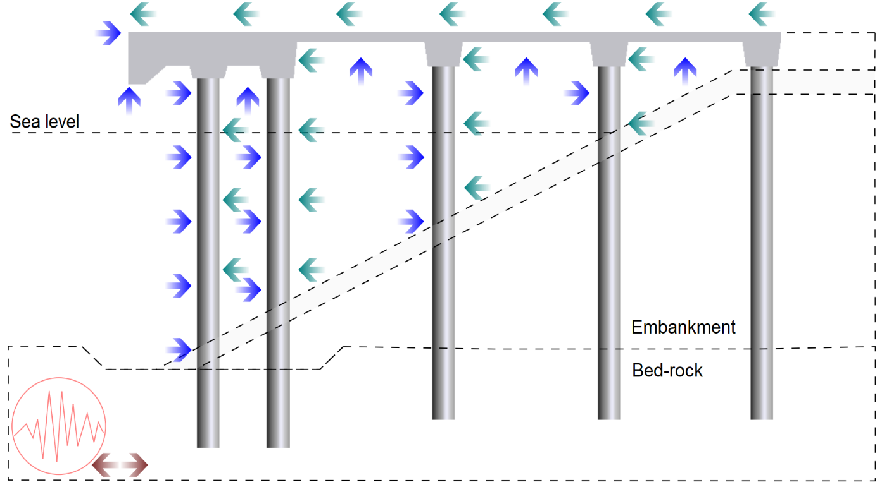
Figure 1 - Elevation view of open-type wharf composed of a soil and infrastructure system subjected to cascading earthquake (brown) and tsunami (blue and green) actions. Seismic forces account for soil-structure interaction. Tsunami forces account for complex geometries and are determined for horizontal and vertical elements, during inflow (blue arrows) and outflow (green arrows) stages of tsunami

