Titletitletitle Titletitletitle Titletitletitle Titletitletitle
Author
Author
Department of Civil and Environmental Engineering
University of XX, City, State
PEER Report [Year/number – to be filled out by PEER.]
Pacific Earthquake Engineering Research Center
Headquarters at the University of California, Berkeley
[Month Year – to be filled out by PEER.]

ABSTRACT
[Sample text, 750 words maximum.] This report describes the design, construction, and shaking table response and computation simulation of a Low Seismic-Damage Bridge Bent built using Accelerated Bridge Construction methods. The proposed bent combines precast post-tensioned columns with precast foundation and bent cap to simplify off- and on-site construction burdens and minimize earthquake-induced damage and associated repair costs. Each column consists of reinforced concrete cast inside a cylindrical steel shell, which acts as the formwork, and the confining and shear reinforcement. The column steel shell is engineered to facilitate the formation of a rocking interface for concentrating the deformation demands in the columns, thereby reducing earthquake-induced damage. The precast foundation and bent cap have corrugated-metal-duct lined sockets, where the columns will be placed and grouted on-site to form the column–beam joints. Large inelastic deformation demands in the structure are concentrated at the column–beam interfaces, which are designed to accommodate these demands with minimal structural damage. Longitudinal post-tensioned high-strength steel threaded bars, designed to respond elastically, ensure re-centering behavior. Internal mild steel reinforcing bars, debonded from the concrete at the interfaces, provide energy dissipation and impact mitigation.
[Paragraph text.] Next paragraph text if needed.
Keywords: [Author to provide 5-7 maximum.]

ACKNOWLEDGEMENTS AND DISCLAIMER
Sed ut perspiciatis unde omnis iste natus error sit voluptatem accusantium doloremque laudantium, totam rem aperiam, eaque ipsa quae ab illo inventore veritatis et quasi architecto beatae vitae dicta sunt explicabo. Nemo enim ipsam voluptatem quia voluptas sit aspernatur aut odit aut fugit, sed quia consequuntur magni dolores eos qui ratione voluptatem sequi nesciunt. Neque porro quisquam est, qui dolorem ipsum quia dolor sit amet, consectetur, adipisci velit, sed quia non numquam eius modi tempora incidunt ut labore et dolore magnam aliquam quaerat voluptatem. Ut enim ad minima veniam, quis nostrum exercitationem ullam corporis suscipit laboriosam, nisi ut aliquid ex ea commodi consequatur? Quis autem vel eum iure reprehenderit qui in ea voluptate velit esse quam nihil molestiae consequatur, vel illum qui dolorem eum fugiat quo voluptas nulla pariatur?
This research study was funded by [FUNDING AGENCY name], under Contract No. #####. The opinions, findings, conclusions, and recommendations expressed in this publication are those of the author(s) and do not necessarily reflect the view of [FUNDING AGENCY name], Pacific Earthquake Engineering Research (PEER) Center, or the Regents of the University of California.

CONTENTS
ABSTRACT iii
ACKNOWLEDGEMENTS AND DISCLAIMER v
CONTENTS vii
LIST OF TABLES ix
LIST OF FIGURES xi
DEFINITIONS AND ACRONYMS xiii
NOTATION xv
1 Introduction 1
2 Literature Review 3
2.1 Hybrid Self-Centering Systems 3
3 Prototype Bridge Study 4
3.1 Hybrid System Model Development and Verification 4
4 Conclusions 9
4.1 Summary 9
4.1.1 Recommendations 9
REFERENCES 11
APPENDIX A CONSTRUCTION DRAWINGS 13

LIST OF TABLES
Table 2.1 Table title. 3
Table 2.2 Table title. 3
Table 3.1 Table title. 5
Table 3.2 Table title. 5
Table A.1 Table title. 13
Table A.2 Table title. 13

LIST OF FIGURES
Figure 2.1 Figure title. 4
Figure 3.1 Figure title. 6
Figure 3.2 Figure title. 7
Figure 3.3 Figure title. 8
Figure A.1 Figure title. 14

DEFINITIONS AND ACRONYMS
(This section is optional)

AASHTO American Association of State Highway and Transportation Officials

…

LRFD Load and Resistance Factor Design

…

LVDT linear variable differential transformer

…

PTFE polytetrafluoroethylene

…

NOTATION
(This section is optional)

A_{tr} area of transverse reinforcement
A_{g} gross cross-sectional area

…

K_{eff} effective stiffness

…

z distance of a point from neutral axis in the direction perpendicular to …

…

α factor indicating the ratio of two parameters of interest

…

Δ change in the lateral displacement

…

μ coefficient of friction

Introduction
Lorem ipsum dolor sit amet, consectetur adipiscing elit, sed do eiusmod tempor incididunt ut labore et dolore magna aliqua. Ut enim ad minim veniam, quis nostrud exercitation ullamco laboris nisi ut aliquip ex ea commodo consequat. Duis aute irure dolor in reprehenderit in voluptate velit esse cillum dolore eu fugiat nulla pariatur. Excepteur sint occaecat cupidatat non proident, sunt in culpa qui officia deserunt mollit anim id est laborum. (Author [et al.] Year). [This is standard format for a REFERENCE.]
Sed ut perspiciatis unde omnis iste natus error sit voluptatem accusantium doloremque laudantium, totam rem aperiam, eaque ipsa quae ab illo inventore veritatis et quasi architecto beatae vitae dicta sunt explicabo. Nemo enim ipsam voluptatem quia voluptas sit aspernatur aut odit aut fugit, sed quia consequuntur magni dolores eos qui ratione voluptatem sequi nesciunt. Neque porro quisquam est, qui dolorem ipsum quia dolor sit amet, consectetur, adipisci velit, sed quia non numquam eius modi tempora incidunt ut labore et dolore magnam aliquam quaerat voluptatem. Ut enim ad minima veniam, quis nostrum exercitationem ullam corporis suscipit laboriosam, nisi ut aliquid ex ea commodi consequatur. Quis autem vel eum iure reprehenderit qui in ea voluptate velit esse quam nihil molestiae consequatur, vel illum qui dolorem eum fugiat quo voluptas nulla pariatur.

Literature Review

Hybrid Self-Centering Systems
[Text example. Note that tables and figures shall be referenced in the text.] At vero eos et accusamus et iusto odio dignissimos ducimus qui blanditiis praesentium voluptatum deleniti atque corrupti quos dolores et quas molestias excepturi sint occaecati cupiditate non provident, similique sunt in culpa qui officia deserunt mollitia animi, id est laborum et dolorum fuga. Et harum quidem rerum facilis est et expedita distinctio. Nam libero tempore, cum soluta nobis est eligendi optio cumque nihil impedit quo minus id quod maxime placeat facere possimus, omnis voluptas assumenda est, omnis dolor repellendus (Author [et al.] Year). [This is standard format for a REFERENCE.] Temporibus autem quibusdam et aut officiis debitis aut rerum necessitatibus saepe eveniet ut et voluptates repudiandae sint et molestiae non recusandae. Itaque earum rerum hic tenetur a sapiente delectus, ut aut reiciendis voluptatibus maiores alias consequatur aut perferendis doloribus asperiores repellat.
Lorem ipsum dolor sit amet, consectetur adipiscing elit, sed do eiusmod tempor incididunt ut labore et dolore magna aliqua. Ut enim ad minim veniam, quis nostrud exercitation ullamco laboris nisi ut aliquip ex ea commodo consequat; see Table 2.1 and Table 2.2. [All tables shall be referenced in text. Place tables close to the location they are mentioned in the text.] Purus sit amet luctus venenatis lectus magna fringilla. Mattis nunc sed blandit libero volutpat sed cras ornare. Feugiat nisl pretium fusce id velit ut tortor. Neque gravida in fermentum et. Orci nulla pellentesque dignissim enim sit amet venenatis. Sit amet porttitor eget dolor. Dolor morbi non arcu risus quis varius. In metus vulputate eu scelerisque felis.
Table 2.1 Table title.
 | Subheading | Subheading | Subheading | Subheading | Subheading
Subsubheading | number | number | number | number | number
Subsubheading | number | number | number | number | number

Table 2.2 Table title.
Additional Subheading | Additional Subheading | Additional Subheading | Additional Subheading | Additional Subheading
Subsubheading | number | number | number | number
Subsubheading | number | number | number | number
Subsubheading | number | number | number | number

Duis aute irure dolor in reprehenderit in voluptate velit esse cillum dolore eu fugiat nulla pariatur; see Figure 2.1. [All figures shall be referenced in text. Place figures as close to the location they are mentioned in the text as practical.] Excepteur sint occaecat cupidatat non proident, sunt in culpa qui officia deserunt mollit anim id est laborum.

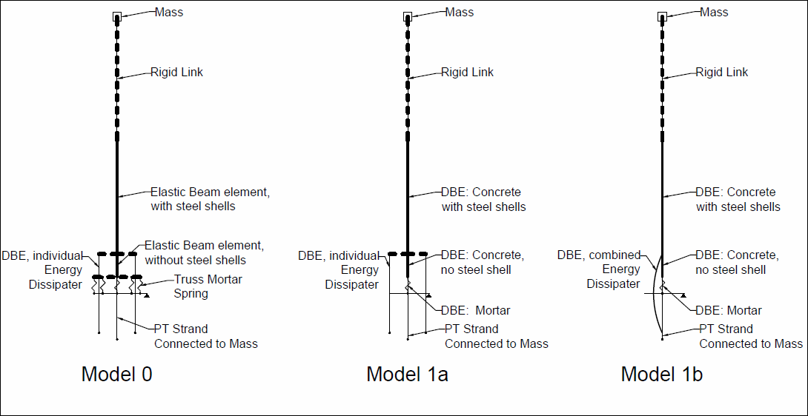
Figure 2.1 Figure title.

Prototype Bridge Study
Lorem ipsum dolor sit amet, consectetur adipiscing elit, sed do eiusmod tempor incididunt ut labore et dolore magna aliqua. Ut enim ad minim veniam, quis nostrud exercitation ullamco laboris nisi ut aliquip ex ea commodo consequat. Duis aute irure dolor in reprehenderit in voluptate velit esse cillum dolore eu fugiat nulla pariatur. Excepteur sint occaecat cupidatat non proident, sunt in culpa qui officia deserunt mollit anim id est laborum.

Hybrid System Model Development and Verification
Sed ut perspiciatis unde omnis iste natus error sit voluptatem accusantium doloremque laudantium, totam rem aperiam, eaque ipsa quae ab illo inventore veritatis et quasi architecto beatae vitae dicta sunt explicabo. Nemo enim ipsam voluptatem quia voluptas sit aspernatur aut odit aut fugit, sed quia consequuntur magni dolores eos qui ratione voluptatem sequi nesciunt. Neque porro quisquam est, qui dolorem ipsum quia dolor sit amet, consectetur, adipisci velit, sed quia non numquam eius modi tempora incidunt ut labore et dolore magnam aliquam quaerat voluptatem. Quis autem vel eum iure reprehenderit qui in ea voluptate velit esse quam nihil molestiae consequatur, vel illum qui dolorem eum fugiat quo voluptas nulla pariatur; see Table 3.1 and Table 3.2. [All tables shall be referenced in text. Place tables close to the location they are mentioned in the text.]
- Bullet one;
- Bullet two; and
- Bullet three
Table 3.1 Table title.
 | Subheading | Subheading | Subheading | Subheading | Subheading
Subsubheading | number | number | number | number | number
Subsubheading | number | number | number | number | number

Table 3.2 Table title.
Additional Subheading | Additional Subheading | Additional Subheading | Additional Subheading | Additional Subheading
Subsubheading | number | number | number | number
Subsubheading | number | number | number | number
At vero eos et accusamus et iusto odio dignissimos ducimus qui blanditiis praesentium voluptatum deleniti atque corrupti quos dolores et quas molestias excepturi sint occaecati cupiditate non provident, similique sunt in culpa qui officia deserunt mollitia animi, id est laborum et dolorum fuga. Et harum quidem rerum facilis est et expedita distinctio. Nam libero tempore, cum soluta nobis est eligendi optio cumque nihil impedit quo minus id quod maxime placeat facere possimus, omnis voluptas assumenda est, omnis dolor repellendus:
A + B + C (3.1)
[Standard format for equation.]
D + E + F (3.2)
[Standard format for equation.]
Lorem ipsum dolor sit amet, consectetur adipiscing elit, sed do eiusmod tempor incididunt ut labore et dolore magna aliqua; see Figure 3.1. [All figures shall be referenced in text. Place figures as close to the location they are mentioned in the text as practical.] Ut enim ad minim veniam, quis nostrud exercitation ullamco laboris nisi ut aliquip ex ea commodo consequat; see Figure 3.2. [All figures shall be referenced in text. Place figures as close to the location they are mentioned in the text as practical.]
Figure 3.1 Figure title.

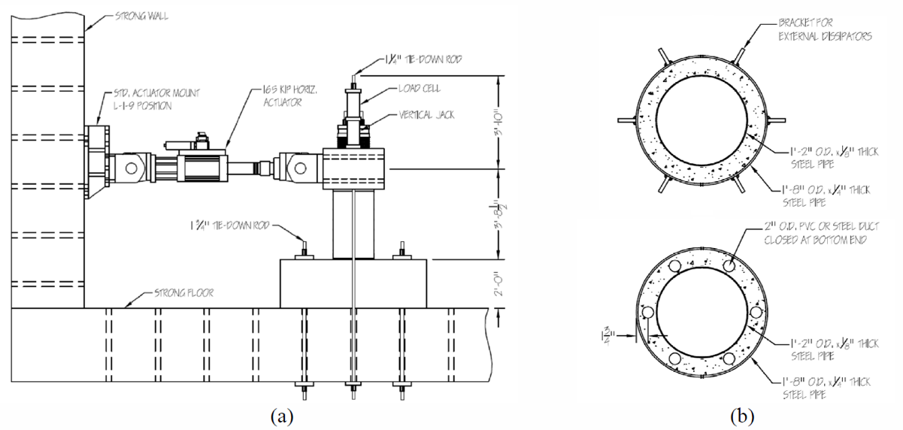
Figure 3.2 Figure title.
Duis aute irure dolor in reprehenderit in voluptate velit esse cillum dolore eu fugiat nulla pariatur. Excepteur sint occaecat cupidatat non proident, sunt in culpa qui officia deserunt mollit anim id est laborum; see Figure 3.3. [All figures shall be referenced in text. Place figures as close to the location they are mentioned in the text as practical.]
Nulla pharetra diam sit amet nisl suscipit. Vel facilisis volutpat est velit egestas dui. Ultricies mi quis hendrerit dolor magna eget est lorem ipsum. Ultrices sagittis orci a scelerisque purus semper eget duis at. Elit ullamcorper dignissim cras tincidunt lobortis feugiat. Aliquam ut porttitor leo a diam sollicitudin tempor id eu. Nulla at volutpat diam ut venenatis. Mauris vitae ultricies leo integer malesuada nunc vel risus commodo. Orci a scelerisque purus semper. Scelerisque purus semper eget duis at tellus at urna. Velit egestas dui id ornare arcu odio. Blandit turpis cursus in hac habitasse. In aliquam sem fringilla ut morbi tincidunt augue. Fermentum iaculis eu non diam phasellus. Magna fringilla urna porttitor rhoncus dolor purus non enim. Vel elit scelerisque mauris pellentesque pulvinar pellentesque. Enim tortor at auctor urna nunc id cursus metus. Augue lacus viverra vitae congue eu. Congue mauris rhoncus aenean vel elit scelerisque mauris pellentesque.

Quisque id diam vel quam elementum pulvinar etiam non quam. Justo donec enim diam vulputate ut pharetra sit. Maecenas accumsan lacus vel facilisis volutpat est velit egestas dui. Diam ut venenatis tellus in metus vulputate eu scelerisque. Rhoncus mattis rhoncus urna neque viverra justo nec. Risus commodo viverra maecenas accumsan lacus vel facilisis volutpat. Nisl nunc mi ipsum faucibus vitae.

Accumsan lacus vel facilisis volutpat est velit egestas dui. At ultrices mi tempus imperdiet nulla malesuada pellentesque elit eget. Rhoncus urna neque viverra justo nec ultrices dui sapien eget. Tempus imperdiet nulla malesuada pellentesque elit eget gravida. At tempor commodo ullamcorper a lacus vestibulum sed. Sapien nec sagittis aliquam malesuada bibendum. Aliquam malesuada bibendum arcu vitae elementum curabitur.

(a) | (b)
Figure 3.3 Figure title.

Conclusions

Summary
Lorem ipsum dolor sit amet, consectetur adipiscing elit, sed do eiusmod tempor incididunt ut labore et dolore magna aliqua. Ut enim ad minim veniam, quis nostrud exercitation ullamco laboris nisi ut aliquip ex ea commodo consequat. Duis aute irure dolor in reprehenderit in voluptate velit esse cillum dolore eu fugiat nulla pariatur. Excepteur sint occaecat cupidatat non proident, sunt in culpa qui officia deserunt mollit anim id est laborum.
- Numbered list here
- Numbered list here
- Numbered list here
- Numbered list here

Recommendations
Sed ut perspiciatis unde omnis iste natus error sit voluptatem accusantium doloremque laudantium, totam rem aperiam, eaque ipsa quae ab illo inventore veritatis et quasi architecto beatae vitae dicta sunt explicabo. Nemo enim ipsam voluptatem quia voluptas sit aspernatur aut odit aut fugit, sed quia consequuntur magni dolores eos qui ratione voluptatem sequi nesciunt. Neque porro quisquam est, qui dolorem ipsum quia dolor sit amet, consectetur, adipisci velit, sed quia non numquam eius modi tempora incidunt ut labore et dolore magnam aliquam quaerat voluptatem. Ut enim ad minima veniam, quis nostrum exercitationem ullam corporis suscipit laboriosam, nisi ut aliquid ex ea commodi consequatur? Quis autem vel eum iure reprehenderit qui in ea voluptate velit esse quam nihil molestiae consequatur, vel illum qui dolorem eum fugiat quo voluptas nulla pariatur?

REFERENCES
[List in alphabetical order by author last name in the format provided below.]
AASHTO (2012). AASHTO LRFD Bridge Design Specifications, 7th ed., The American Association of State Highway and Transportation Officials, Washington DC.
Akkar S., Çağnan Z. (2010). A local ground-motion predictive model for Turkey, and its comparison with other regional and global ground-motion models, Bull. Seismo. Soc. Am., 100(6):2978–2995, doi: 10.1785/0120090367.
Alawaji H., Runesson K., Sture S., and Axelsson K. (1992). Implicit integration in soil plasticity under mixed control for drained and undrained response, Int. J. Num. Anal. Meth. Geomech., 16(10:737--756), doi: 10.1002/nag.1610161004.
Alawaji H.A.S. (1990). Formulation and Integration of Constitutive Relations in Soil Plasticity under Mixed Control for Drained and Undrained Control, PhD thesis, University of Colorado at Boulder, Boulder, CO.
Andrus R.D., Stokoe K.H. (2000). Liquefaction resistance of soils from shear wave velocity, J. Geotech. Geoenviron. Eng., 126(11): 1015–1025.
Armstrong R.J., Boulanger R.W., Beaty M.H. (2013). Liquefaction effects on piled bridge abutments: centrifuge tests and numerical analyses, J. Geotech. Geoenviron. Eng., 139(3):433–443, doi: 10.1061/(ASCE)GT.1943-5606.0000780.

APPENDIX A CONSTRUCTION DRAWINGS
[Text, tables, and figures in Appendices use the same format as each Chapter in the main body of the report. Tables and figures shall be referenced in text. Text is followed by all tables, then by all figures.] Lorem ipsum dolor sit amet, consectetur adipiscing elit, sed do eiusmod tempor incididunt ut labore et dolore magna aliqua. Ut enim ad minim veniam, quis nostrud exercitation ullamco laboris nisi ut aliquip ex ea commodo consequat. Duis aute irure dolor in reprehenderit in voluptate velit esse cillum dolore eu fugiat nulla pariatur; see Table A.1 and Table A.2. [All tables shall be referenced in text.] Duis aute irure dolor in reprehenderit in voluptate velit esse cillum dolore eu fugiat nulla pariatur; see Figure A.1. [All figures shall be referenced in text.] Excepteur sint occaecat cupidatat non proident, sunt in culpa qui officia deserunt mollit anim id est laborum.
Table A.1 Table title.
Additional Subheading | Additional Subheading | Additional Subheading | Additional Subheading | Additional Subheading
Subsubheading | number | number | number | number
Subsubheading | number | number | number | number
Subsubheading | number | number | number | number

Table A.2 Table title.
Additional Subheading | Additional Subheading | Additional Subheading | Additional Subheading | Additional Subheading
Subsubheading | number | number | number | number
Subsubheading | number | number | number | number
Subsubheading | number | number | number | number

Figure A.1 Figure title.

All new chapters must start on an odd page.
All computer program citations and anything that isn’t strictly a journal, conference proceeding, or a standard should be cited as a footnote.
ALL journal articles must include their DOI’s.

